CAMBODIA GOVERNMENT-PRIVATE SECTOR FORUM (G-PSF)

EXIT WITH SUCCESS

By Dr Lili Sisombat
Project manager, G-PSF
IFC Advisory Services – Cambodia
Presentation made at the Global Public/Private Dialogue Workshop
Vienna, 26 April 2009

1 - CONTEXT AND UNIQUE FEATURES

Cambodia’s Government-Private Sector Forum (G-PSF), established at the initiative of the Royal Government of Cambodia in 1999, is a mechanism for public/private sector consultation on investment climate issues ranging from long range policy to day-to-day operations. The G-PSF also gives Government a channel for getting private sector feedback on draft policies, laws and regulations. Chaired by the Prime Minister, the G-PSF has two plenary meetings a year which have the status of cabinet meetings, and decisions made by the Prime Minister are binding.

The sub-decree establishing the G-PSF sets out its objectives as follows:

-Discuss and exchange ideas with private sector dialogue partners to identify measures that resolve complaints in individual sectors in a timely manner, and propose these solutions to the authorities concerned.
-Identify, in consultation with private sector dialogue partners, strategic initiatives for supporting and encouraging existing companies as well as attracting investors that will bring new businesses to Cambodia.
-Provide a regular report to the Head of the Royal Government on the activities and direction for follow-up work, which is required for continuous implementation so that the Head of the Royal Government can propose solutions at the twice-yearly plenary sessions.
-Address other problems as necessary within the framework of individual sector meetings and as mandated by the Royal Government.

From the very beginning of the G-PSF, the Government has played a very strong leadership role in management of the dialogue, while the private sector has lagged behind in terms of organizing itself and in substantiating the problems raised with Government. Since 2002, at the request of the Government, IFC has supported a G-PSF Coordinating Bureau to help the private sector advocate more successfully for itself. At any time, the PSWGs and Government counterparts are negotiating solutions to more than 300 different problems.

Since IFC’s involvement began in 2002, the dialogue between the Government and the private sector has matured, and the private sector now shows sufficient capacity to engage directly with their Government counterparts. Therefore, IFC has started working with stakeholders on an exit strategy.

The main reason why the Forum has been so successful is the strong commitment from both Government and the private sector. Jointly they contribute hundreds of hours a year to Forum Working Group meetings and other activities. Also because the Government and the private sector have taken ownership of PPD, they consider this as the key channel for raising problems and resolving them.

The plan for IFC to exit and fully leave management of the G-PSF in the hands of the private sector is a first of its kind and the lessons learned from this exercise will definitively influence the way IFC-WB manages its exit from the other 30 or so public/private dialogues they currently support.

2 – STRUCTURE OF THE G-PSF

This section summarizes the structure and roles of the key bodies taking active part in Cambodian public/private dialogue and how they interact.
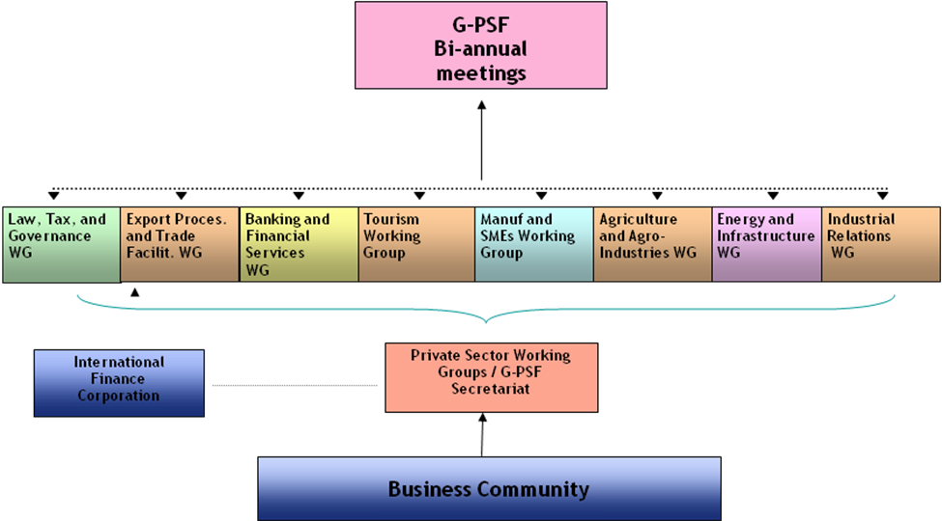

- The Working Groups

Throughout the year, eight private sector working groups (PSWGs) meet regularly to identify and prioritize common problems, and negotiate solutions with Government counterparts. These groups are currently as follows:

- Agriculture and Agro-industry
- Tourism
- Manufacturing and Small and Medium Enterprises
- Law, Tax and Governance
- Banking and Financial Services
- Export Processing and Trade Facilitation
- Energy, Transport and Infrastructure
- Industrial relations

The private sector and Government meet as often as necessary, and at two levels:
(i) Private sector-only working group (PSWG) meetings, which are open to business associations and company representatives, allow members to discuss and agree internally on issues to raise with their Government counterparts. These PSWGs meet every month or so. The agenda of issues to discuss with Government is prepared following broad consultation. IFC organizes and hosts many of these PSWG meetings, coordinates the nominations and elections of the Private Co-Chair for each working group, and encourages inputs from national and international private sector members.
(ii) Joint Government-Private Sector Working Group (WG) meetings take place at the request of the private sector or the Royal Government of Cambodia to discuss problems, find solutions, and share information raised by the parties. Each Government-Private Sector Working Group is co-chaired by a Minister of the Royal Government of Cambodia (the Government Co-chair) and a representative from the private sector (the Private Sector Co-chair). These WG meetings are attended by representatives of the line ministries who have been invited by the Government co-chair so that these Government officials can provide solutions to the problems raised by the private sector and report progress back to their senior management.

The WG meetings discuss an agreed-on agenda of problems and recommendations related to either law or policy (e.g. laws, sub-decrees, prakas, decisions) or direct operational impediments experienced by the private sector (e.g. road conditions, unofficial fees, damaged infrastructure). Outstanding issues that are not resolved within the WG dialogue can be referred to the Prime Minister for resolution during the twice-yearly Forum plenary sessions.

As the WG meetings are attended by top ranking representatives of relevant ministries, the G-PSF plays a key role in fostering intra-governmental coordination and information exchange on private sector development matters.

- Executive Co-Chairs Working Group
To facilitate collaboration across the Working Groups, all eight Private Sector Working Group Co-Chairs meet together at least once a quarter to discuss common concerns and strategize how to resolve these as a group.

- The bi-annual plenary meeting “The Forum”

Twice a year, the G-PSF holds a formal, nationally-televised plenary meeting which brings together the Prime Minister, key cabinet ministers, and some 600 business leaders, government officials, journalists and development partners. During these plenary sessions, the Private Sector Working Groups raise issues they have not been able to resolve with Government counterparts and ask for the Prime Minister’s ruling. Since these plenary meetings have the status of cabinet meetings, decisions made by the Prime Minister are binding.

- The G-PSF General Secretariat – Council for the Development of Cambodia (CDC)
A Prime Minister’s Sub-Decree (Sub-Decree on the Establishment of Sectoral Working Groups for Dialoging with the Private Sector, 7-SSR, 2001) assigns the CDC as the General Secretariat for facilitation of the G-PSF mechanism. The CDC currently manages information flow and coordination for the Government, and provides the logistical and organizational support required for the Forum plenary sessions, as well as the venue for holding them.

Deputy Prime Minister and Minister of Finance, H.E. Keat Chhon, acts as the Forum’s Coordinator, and H.E. Sok Chenda, Minister attached to the Prime Minister and Secretary General of the CDC, acts as its Secretary General. The Chairman of the G-PSF is the Prime Minister himself.

- IFC Coordinating Bureau

Since 2002, IFC has supported a Coordinating Bureau which provides secretarial and coordinating functions for the eight Working Groups. From 2002 until 2007, this work was co-funded by the Government of Australia, through AusAID.

The Coordinating Bureau, which works in close collaboration with the G-PSF Secretariat that is operated by the Council for the Development of Cambodia, facilitates dialogue within and among the joint government/private sector Working Groups, and broadly, between the Government and the business community.

Initially, IFC’s efforts were mostly devoted to getting the partners to sit down together and discuss solutions to the issues raised by the private sector. In addition to facilitating meetings of the eight Working Groups, the Coordinating Bureau also monitors and records progress in resolving the issues the Working Groups have raised with their Government counterparts and posts these and other relevant documents on a website IFC supports (www.cambodia-gpsf.org).

IFC’s focus has now shifted to aid working groups in advocating for reform through conducting selected research. IFC is also working with other development partners such as USAID, GTZ, UNDP, and The Asia Foundation to expand dialogue at the provincial level and provide more support for research related to reform proposals.

IFC supports the G-PSF because it is a useful tool for improving the business environment and it is the only formal mechanism in Cambodia for companies or individuals who want to raise business-related problems with the Government and seek solutions to them.

3 – G-PSF EVALUATION RESULTS
In an independent evaluation in 2007, the Forum received high marks for organizational effectiveness and impact on the reform process. The evaluation also cited examples for judging the Forum’s economic impact. These include:

- An estimate of US$350,000 per year for the pro bono input business leaders provide to the Forum through their participation in the Working Groups. This compares very favorably with the Forum’s annual donor funding of US$160,000.
- An estimate of US$70 million in money saved by the private sector on a sample of only nine reforms evaluated, out of nearly one thousand raised with the Government.
- A return of $US 105 for each dollar invested in the Forum by the International Finance Corporation and other donors.

The G-PSF evaluation also noted other successes, as follows:
- Significant reforms can be attributed, at least in part, to the G-PSF.
- The dialogue process is seen in and of itself as a positive outcome for the reform process, and for many respondents, as a significant achievement.
- The G-PSF has opened communication and advocacy channels which did not exist before, as well as expanding pre-existing channels to new groups, allowing reform issues to be considered, accelerated and successfully resolved by the Royal Government of Cambodia.
- The Royal Government of Cambodia uses public/private dialogue to improve its own communication, coordination and internal accountability.
- G-PSF impact assessment demonstrates a strong, measurable economic impact from the G-PSF.
- While large trends in investor confidence and growth cannot be attributed (positively or negatively) to the G-PSF, analyses suggest that sub-indicators of business climate effectiveness are positively influenced by the Forum.

In a review conducted in 2008 of 31 PPD supported by the World Bank Group world wide, the G-PSF was rated as among the top performers.
Asked why the G-PSF is so successful, both Government and private sector members have told evaluators that the most important factor is strong commitment from both. IFC also considers the Prime Minister’s support a prime factor for success. The Prime Minister inaugurated the Forum in 1999 and chairs its twice-yearly plenary sessions which are broadcast on all TV stations nationwide.

4 – IFC EXIT STRATEGY FOR THE G-PSF

Over the period of 2008-2011, IFC will work with key Cambodian business associations to develop their capacity to play a greater role in administering the G-PSF, commissioning research and undertaking advocacy.

Future structure of the G-PSF
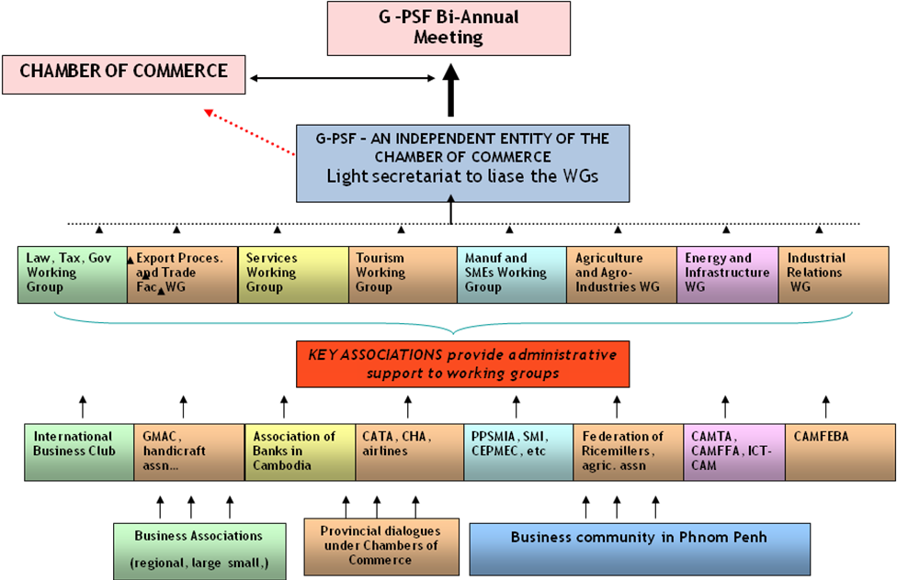

- Business Associations as PSWG Secretariats
To ensure the sustainability of the G-PSF, business associations will need to play a greater role in the management of the WGs and perform the role of PSWG secretariat. Some working groups such as Law, Tax and Governance; Banking and Financial Services; Export Processing and Trade Facilitation; and Industrial Relations are already supported by associations that play a leading role in managing group activities and reporting to their constituents. These business associations will gradually take over roles and responsibilities that used to be undertaken by IFC’s Coordinating Bureau. Despite some success with this hand over, the working group process remains largely that of participation by individual business representatives, with IFC continuing to facilitate the process.

5 – Challenges to overcome

Capturing impact: despite a sophisticated M&E framework developed by the network of PPD practitioners - which was used in the evaluation of the G-PSF in 2007 - a key challenge faced by the coordination team is that of reporting on the impact of public/private dialogue using the IFC monitoring indicators. This is crucial in order to demonstrate its real value to IFC management. Increasingly, the IFC monitoring and evaluation indicators that we are expected to track are defined according to IFC business lines and core products, which are, by definition, limited. For example, the indicator on the “number of laws, regulations, amendments, codes that were eliminated/improved” limits the “count” to only the areas where IFC has provided technical assistance. However, technical assistance can only be provided if it corresponds to core IFC products. On the contrary the issues raised by PPD cover a number of sectors and encompass hundreds of areas of reform. Establishing a PPD that covers only IFC core products will be of limited use for Government and private sector participants, because instead of focusing on the priorities of stakeholders, we will be focusing on IFC’s priorities.
On the sustainability plan, there are several major risks to be considered:
Weak associations: The model for the sustainability of the G-PSF is that business associations will take over managing administration of the G-PSF. Currently, although some are well organized, most Cambodian business associations are weak, and lack both sufficient members and adequately skilled management. Even after receiving two years of capacity building through IFC, business associations may still not be able to deliver the services required of a secretariat to a Private Sector Working Group.
Lack of an institutional home for the G-PSF: A second key risk is that there is no document describing the operations of the G-PSF. Currently the sub-decree issued by the Government covers only the Government’s mandate and operational procedures on how to participate in the G-PSF, but does not cover the roles and responsibilities of the private sector. By-laws for the proposed private sector umbrella (the Private Sector Forum) have been developed with support from IFC, but these bylaws have not yet been endorsed by the Government and other stakeholders. According to these by-laws, the G-PSF will become an independent entity under the umbrella of the Cambodia Chamber of Commerce. If this model is not adopted, it could cause existing Private Sector Working Group members and their Co-chairs to disengage from the dialogue because they fear loss of their independent views and that their problems will not be accurately reported to, or addressed by, Government.
Lack of capacity: Due to lack of capacity (financial and human resources) or their lack of commitment to ensure outreach, when business associations act as secretariats to the Working Groups, they could call only upon their members, and in doing so, cut out other important companies and sectors that participate in the PSWGs. For example, the export processing working group could reflect only the concerns of the garment manufacturers’ association, rather than the concerns of other exporters such as the exporters of handicrafts and of agricultural products. The dialogue could then shrink to a bilateral dialogue (between one association and its Government counterpart), instead of covering cross-cutting issues from several sectors. An associated risk is that the Forum will no longer represent the Cambodian private sector as a whole, but will degenerate into a number of parallel dialogues that are uncoordinated with each other. This would weaken the PSWGs capacity to advocte and also cause confusion for the Government which would not like to negotiate with so many separate entities and would no longer have coordinated views from the private sector as a whole.
Lack of advocacy skills: Lack of business association capacity may also be reflected in the difficulties associations have in clearly articulating problems and finding the statistics and other evidence needed to explain problems and proposed solutions. Because business associations can only afford to hire junior staff who have limited education and training, staff will likely not have the capacity to prepare effective position papers. The key risk here is that PPD becomes an ‘empty egg’ with little impact on the reform process.
IFC is addressing these risks in working closely with the Government to set up a clear institutional framework for the private sector to operate, and in increasing the capacity of the Government to monitor the impact of the dialogue and the effectiveness of the Private Sector Working Groups. If the quality of the discussion were to decrease, the Government’s role will be to demand that the private sector provides better inputs in the dialogue. There is still a role for IFC and other donors to support the private sector with sectoral research and expertise on issues raised. IFC plans to continue such support in the future. From the associations’ side, IFC’s intervention has its limits as the private sector is young and many business owners still lack formal education. As the private sector grows in Cambodia and access to education improves, it is expected that business associations will grow stronger themselves.

6 - RECOMMENDATIONS

As the G-PSF embarks on empowering the private sector to manage the dialogue and undertake direct consultation with the Government, there are some lessons which can be shared with other PPDs.

a – Do not create a PPD secretariat in the aid agency
The secretariat should be embedded in both Government and private sector institutions. The Government’s PPD secretariat coordinates with various public institutions and the private sector’s PPD secretariat coordinates with various business membership organizations (chambers of commerce and industry associations). Ideally the national chamber of commerce should play this role, but it could be that the chamber will have so little capacity that solutions will need to be found that utilize other business membership organizations (such as the local employers’ association).

Entrusting stakeholders to run the secretariat from the inception of a forum is necessary because:
- sustainability is worked towards from the start;
- the PPD belongs to the Government and to the private sector, not to the aid agency
- development partners have their own agenda and priorities, which are not always consistent with those from the private sector or Government.

Development partners have now developed well-designed tools that they can provide to these PPD secretariats and a network of PPD experts can be assigned as advisors. These PPD experts should be contracted initially for one year or more, but should not lead dialogue management. Rather, these PPD experts should be in the background, providing advice, training, setting up an M&E system, ensuring outreach and helping to build trust.

b – PPD needs endorsement from the highest level of authority
To achieve reforms and ensure commitment from Government institutions to listen to the private sector, it is crucial that the PPD is chaired by the highest level of authority, whether the Prime Minister or the President. Without such authority, there is no motivation for Government officials to address the needs of the private sector, especially when issues have to be resolved through inter-ministerial cooperation. In the case of Cambodia, the Prime Minister is making PPD relevant for all PSD initiatives and encouraging Cambodian agencies to consult with the private sector. This consultation was particularly crucial in early 2009, when the Government needed private sector inputs on how to resolve the current economic crisis. Thus PPD needs a legal mandate which covers both Government and private sector roles, defines who participates and clearly sets the objectives.

c – Provide support to the private sector and to the Government to make good decisions
In frontier countries like Cambodia, the private sector is young and not organized. Eighty seven percent of provincial businesses are not fully registered and 80% of the population is rural. The capacity of the private sector to articulate problems and recommend solutions, especially on strategic concerns, is limited. The private sector’s comprehension of national and international laws/environment is also limited. To support the issues raised, there is a role for development partners to provide research, expertise and ad-hoc advice. However, development partners should be willing to fund consulting assignments and research in areas proposed by stakeholders, and not limit their assistance to what matches the donor agency’s agenda.

7 – Details of the Author
Dr Lili Sisombat is project manager for the IFC Coordinating Bureau of the Government-Private Sector Forum. Before taking on this role, she was program manager for Business Edge Cambodia and Lao PDR in the IFC Mekong Private Sector Development Facility and manager of IFC PEP China’s Management Development Program. She joined IFC in 2001. Lili holds a masters degree in business management and a PhD in sociology (both from France). Before joining IFC, Lili worked in marketing for multi-national companies in Europe, and then in the early 1990s, returned to live and work in Lao PDR, her native country, where she ran a consulting and market research company.
Contact : lsisombat@ifc.org

Source: 2008 Provincial Business Environment Scorecards, IFC and Asia Foundation

